
PROJECT REPORT
(Project Semester October– December 2025)
Marine Benthic Biodiversity & Abundance Analysis Dashboard
Submitted by:
Name: Tunga Durga Sai Prasad
Registration No: 12306404
Programme and Section: B. Tech CSE K23CG
Course Code: INT374
Department of Computer Science and Engineering
Lovely Professional University
Phagwara, Punjab (India)
December 2025

Under the Guidance of
Dr. Ashu (UID: 23631)
Discipline of CSE/IT
Lovely School of Computer Science and Engineering
Lovely Professional University, Phagwara

CERTIFICATE
This is to certify that Tunga Durga Sai Prasad, bearing Registration No. 12306404, has successfully completed the project work entitled “Marine Benthic Biodiversity & Abundance Analysis Dashboard”
as part of the course INT374 during the project semester October– December 2025, under my supervision and guidance. To the best of my knowledge, the present work is the result of the student’s original research, development, and effort.
Signature and Name of the Supervisor
Dr. Ashu
Assistant Professor, Discipline of CSE/IT
School of Computer Science and Engineering
Lovely Professional University, Phagwara, Punjab
Date: ______________________

DECLARATION
I, Tunga Durga Sai Prasad, a student of B. Tech under the CSE/IT Discipline at Lovely Professional University, Punjab, hereby declare that the project work entitled
“Marine Benthic Biodiversity & Abundance Analysis Dashboard” submitted in partial fulfilment of the course INT374, is the result of my own intensive work. The content in this report is original, genuine, and has not been copied from any unauthorized source. All efforts and data analysis have been conducted with sincerity and academic integrity.
Date: 21-12-2025
Signature: ______________________
Reg No.: 12306404
Name of the Student: Tunga Durga Sai Prasad

ACKNOWLEDGEMENT
I would like to express my sincere gratitude to all those who supported me throughout the completion of this project-titled “Marine Benthic Biodiversity & Abundance Analysis Dashboard”-First and foremost, I would like to thank, my respected project supervisor, for her invaluable guidance, support, and encouragement. Her expert advice, timely feedback, and motivation helped me stay focused and complete this project efficiently.
I would also like to extend my appreciation to the faculty and staff of the Discipline of CSE/IT, Lovely Professional University, for creating a learning environment that inspired this research.
A special thanks to my peers, friends, and family for their constant moral support and encouragement throughout the project.
Lastly, I would like to acknowledge the use of the dataset provided by U.S. Educational Services,
which served as the foundation for the analysis conducted in this report.

Tunga Durga Sai Prasad
Registration No.: 12306404

TABLE OF CONTENTS

- Introduction
- Source of Dataset
- Sample Dataset
- Dataset Preprocessing
- Dashboard Overview
- Cards
- GIF-Based Navigation in Power BI Dashboard
- Conclusion
- Future Scope
- References
- LinkedIn
- GitHub
- Project Link

1. Introduction
Marine benthic ecosystems play a vital role in maintaining ocean health by supporting biodiversity, nutrient cycling, and food webs. Understanding the diversity, abundance, and distribution of benthic organisms is essential for ecological monitoring and environmental decision-making.
This project focuses on analysing marine benthic biodiversity and abundance patterns using a structured dataset and visualizing key insights through an interactive Power BI dashboard. The dashboard enables users to explore species distribution, taxonomic classification, depth-wise abundance, and site-wise variation in an intuitive and analytical manner.

2. Source of Dataset
The data used for this project was obtained from Data.gov, the official open data portal of the U.S. Government.
Specifically, the dataset is titled “Marine Benthic Abundance Data”, which contains comprehensive records of marine benthic species observations, including taxonomic classification, species abundance, sampling locations, and environmental parameters.

Dataset Link:- https://catalog.data.gov/dataset/marine-benthic-abundance-data

3. Sample Dataset
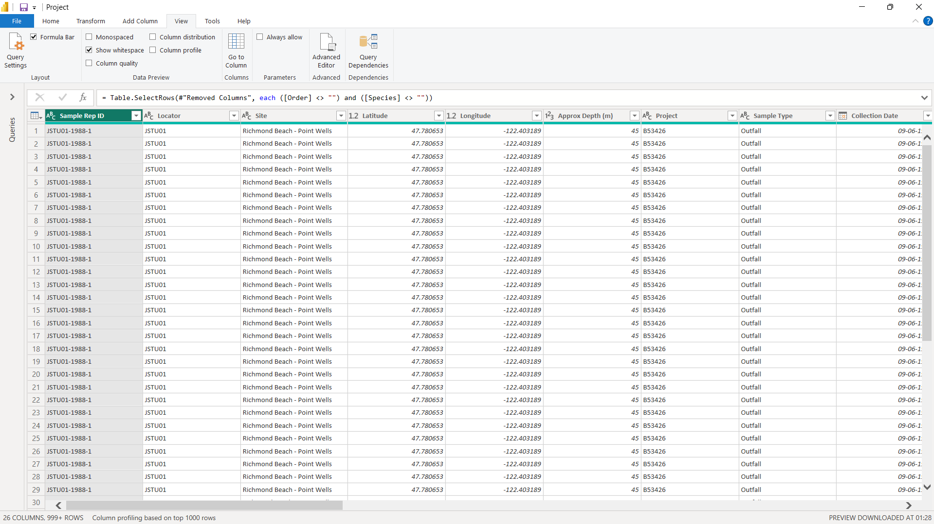

4. Dataset Preprocessing
Before visualization, the dataset underwent several preprocessing steps to ensure accuracy and performance in Power BI:
- Removed null and duplicate records
- Standardized taxonomic names and classifications
- Converted abundance and depth fields to numeric formats
- Created calculated columns and measures (Total Abundance, Average Abundance, Species Count)
- Established relationships and hierarchies for taxonomy (Phylum → Class → Genus)
- Optimized data model for faster filtering and interaction
These steps ensured clean, reliable, and analysis-ready data.
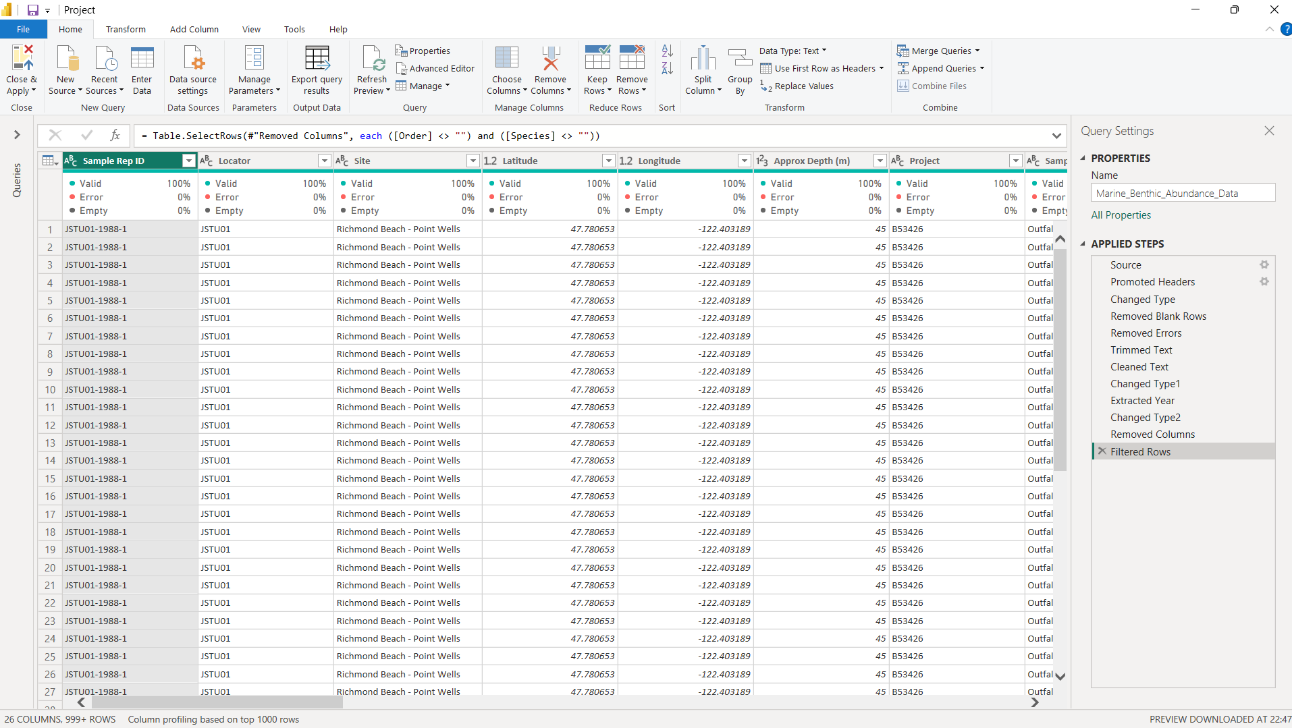

5. Dashboard Overview
The Marine Benthic Biodiversity & Abundance Analysis Dashboard consists of four interactive pages, each designed with a specific analytical focus:
🔹 Home Page
- Project introduction and navigation
- High-level explanation of dashboard purpose
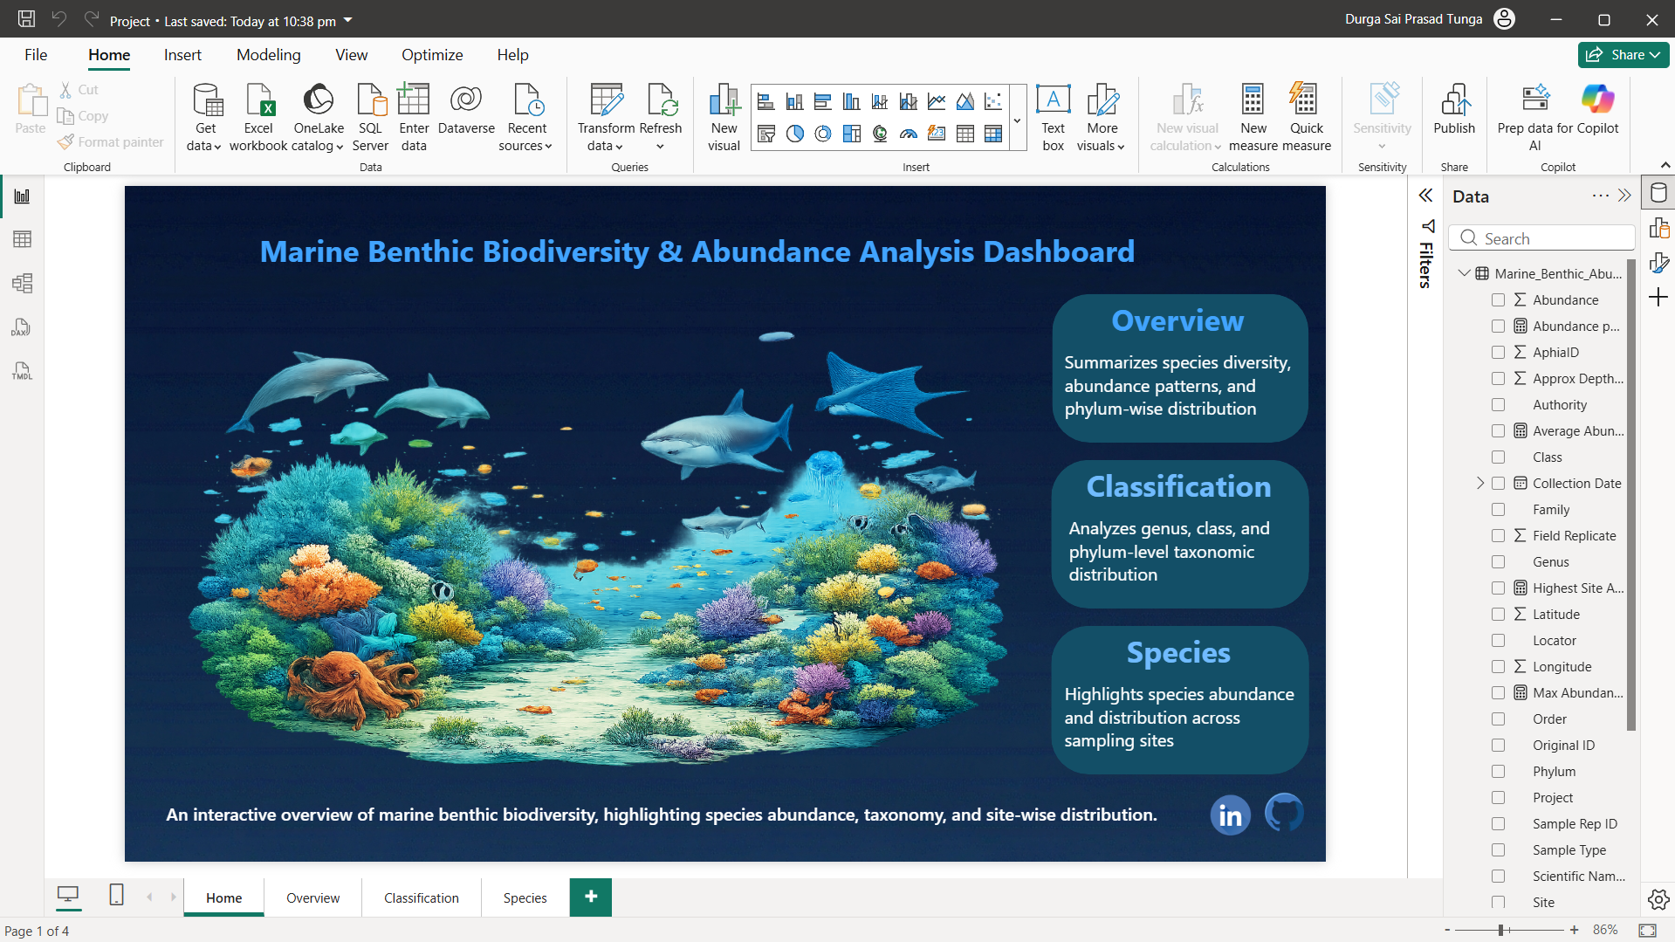

🔹 Overview Page
- Total Species and Total Abundance KPIs
- Phylum-wise contribution to total abundance
- Abundance vs. depth analysis
- Species-wise abundance distribution

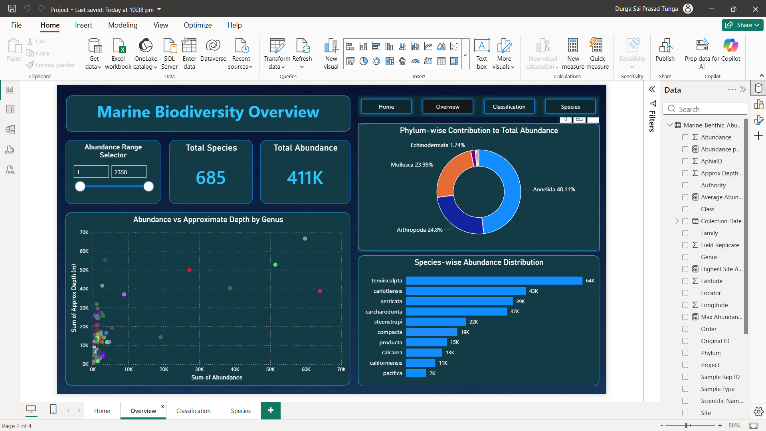

🔹 Classification Page
- Taxonomic structure across classes and genera
- Average abundance and AphiaID analysis
- Authority-wise genus count
- Interactive taxonomic flow visualization

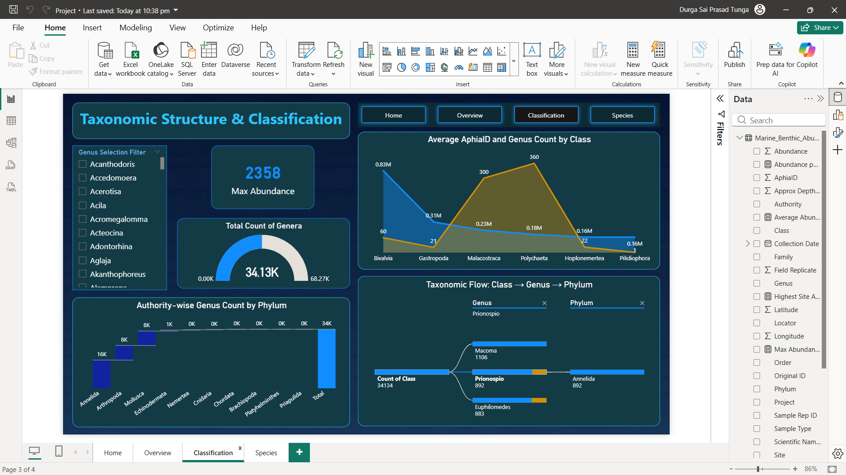

🔹 Species Page
- Site-wise species abundance
- Top sampling sites
- Genus and class distribution
- Detailed tabular view for comparison
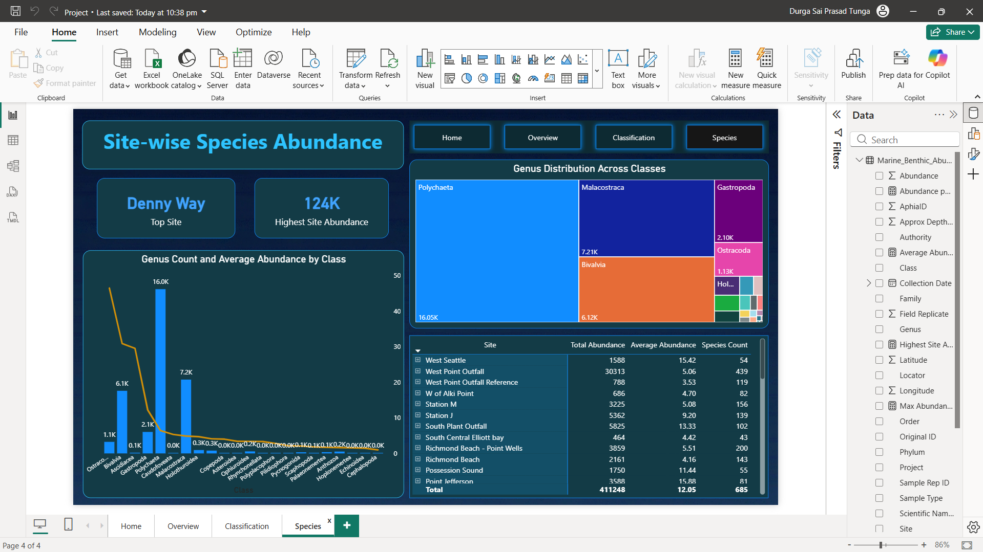
The dashboard enables dynamic filtering, drill-down analysis, and cross-page insights.

6. Cards
Cards are used to highlight key summary metrics for quick understanding:
- Total Species – Total number of unique species recorded
- Total Abundance – Overall count of organisms across all sites
- Max Abundance – Highest abundance recorded for a single species
- Top Site – Sampling location with the highest biodiversity

7.GIF-BASED NAVIGATION IN POWER BI DASHBOARD
To enhance user experience and interactivity, GIF-based navigation buttons were implemented within the Power BI dashboard. Animated icons were used to create intuitive page transitions between Home, Overview, Classification, and Species pages.
Each GIF button is configured using Page Navigation actions, allowing users to move seamlessly across dashboard pages. This approach improves usability, provides a modern visual appeal, and helps users understand dashboard flow without additional instructions.

8. CONCLUSION

This project successfully presents an interactive and visually compelling analysis of marine benthic biodiversity and abundance using Power BI. By integrating taxonomic classification, species distribution, depth analysis, and site-wise abundance, the dashboard enables meaningful ecological insights.
The use of dynamic filters, KPI cards, and advanced visualizations allows stakeholders to explore complex marine data efficiently. Overall, the project demonstrates effective data preprocessing, analytical thinking, and professional dashboard design.

9. FUTURE SCOPE
The project can be further enhanced in several ways:
- Integration of time-series data to analyze seasonal or long-term biodiversity trends
- Inclusion of environmental parameters such as temperature, salinity, and sediment type
- Deployment of predictive analytics to forecast species abundance using machine learning
- Publishing the dashboard via Power BI Service for real-time collaboration
- Extending the analysis to global marine datasets for comparative studies

10. REFERENCES
- U.S. Government Open Data Portal. Marine Benthic Abundance Data. Data.gov.
https://catalog.data.gov
- Microsoft. Power BI Documentation.
https://learn.microsoft.com/power-bi
- Microsoft. Power BI Desktop – Data Modeling and DAX Reference.
https://learn.microsoft.com/dax
- World Register of Marine Species (WoRMS). Marine Taxonomic Database.
https://www.marinespecies.org

11. LinkedIn
https://www.linkedin.com/feed/update/urn:li:activity:7408216018034102272/

12. Github
https://github.com/durgasaiprasad06/Marine-_Benthic_Biodiversity_-_Abundance_Analysis_Dashboard
13. Project Link
https://drive.google.com/file/d/12nNlkNZRPb43cthwfqrB3oY08rPQURgj/view?usp=drive_link

